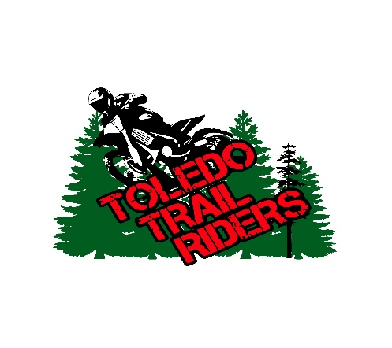
Dear Member,
Thank you for your interest in the Toledo Trail Riders, Northwest Ohio and Southeast Michigan’s only Non-Profit Off-road All Purpose Vehicle club. As dedicated enthusiasts, we share a passion for off-road motorcycle and ATV riding. Our primary mission is to promote family friendly, environmentally-responsible riding habits, and protecting the Maumee State Forest APV area. Throughout the season, we host a variety of activities such as trail rides, clean-up days, charity events and other family-oriented activities. We have built a strong and strategic partnership with the Ohio Department of Natural Resources, who manages the Maumee State Forest APV area, and all other public lands in Ohio. The Toledo Trail Riders invite you to join the organization to ensure that local off-road riding opportunities are ensured for generations to come. The future begins with YOU! We need YOU to help shape, protect, lead, and continue spreading the enjoyment of off-road riding at the Maumee State Forest APV area, and all off-road riding opportunities. We want to be known as a group of “doers”, resting on our laurels is not an option. But with your passion, excitement, and cooperation, we will have strength in numbers, and great things and opportunities have and will come from that.

The subsequent page takes you through some of our accomplishments, at not only at the Maumee State Forest APV area, but on a state and national level as well. Also included are the reasons why you, your family, and your riding buddies should join the Toledo Trail Riders. The last page enclosed is applicable membership options, signature section, and contact information. We hope you strongly consider joining our club!
If you have any questions, please do not hesitate to contact us. You can contact me direct at (419) 392-7117, email at mbucher@toledotrailriders.org, or find us on Facebook at www.facebook.com/toledotrailriders.
On behalf of our Board of Directors, we appreciate your time, support, and thank you for your commitment to the mission!
Sincerely,
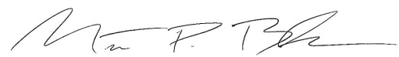

Matthew P. Bucher
President

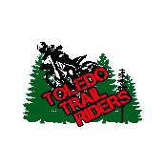
Our Top 10 List of Accolades and Accomplishments of the Toledo Trail Riders:
- Since our founding in 2008, there have been Zero Rider Fatalities at the Maumee State Forest APV area.

- A major Reduction of Crash Related Injuries by APV riders, at the Maumee State Forest APV

- Trails have been Re-Routed to Reduce Speeds and make a more Enjoyable Trail System.

- 2.5 Miles of Additional Trail that was incorporated into the existing trail system in 2011.

- APV Parking Lot was doubled in sized and paved.

- TTR has joined the AMA (American Motorcyclist Association) and ATVA (All-Terrain Vehicle Association) as a Charter Club.

- Introduced the first ever public single-track trail in Ohio at the Maumee State Forest APV Area

- TTR has coordinated the First Ever Charity Event at the Maumee State Forest APV Area, with the “Laps for Hannah’s Socks” event.

- TTR has been recognized by national trail advocacy groups such as AMA (American Motorcyclist Association), NOHVCC (National Off-Highway Vehicle Conservation Council), and The Cycle Conservation Club of Michigan.

- TTR has a seat on the SRV (State Recreational Vehicle) provisional board at the ODNR- You are Heard!

Why YOU should join the Toledo Trail Riders!
Make a Difference – Join the fastest growing group of passionate off-road enthusiasts with a track record of improving, expanding, and implementing safer, more enjoyable trails at the Maumee State Forest APV area. We also work closely with state and local officials to help shape issues that affect all APV users in Ohio.

Be a Part of Off-Road Environmental Stewardship – Promote environmental education to the off-road community with an understanding of our impact on the environment and surrounding community. This includes APV sound limitations, use of spark arrestors, safe riding habits, off-trail riding, permits and licensing, and where to access legally designated riding areas.

Get Active - Our activism in working with AMA (American Motorcyclist Association), ODNR (Ohio Department of Natural Resources), other APV clubs such as OMTA (Ohio Motorized Trails Association) help build relationships and coalitions to improve the experience of off-road riding not only at the Maumee State Forest APV area, but throughout all of Ohio. One voice can seldom produce change, but many voices will.

Help Guide Toledo Trail Riders – Help guide us on formulating proposals and ideas to improve the Maumee State Forest APV trail system, and other APV trail systems in Ohio. One-way traffic, safer trail layout and design, and larger, more user friendly parking lot design are some of the recent ideas we have submitted and were implemented.

Charity Outreach – Toledo Trail Riders have partnered with various organization to raise funds and provide essential necessities for those less fortunate

Clean-up Days – Join us on clean-up days to help keep the Maumee State Forest APV area a clean, natural trail system to enjoy while building goodwill with ODNR, local authorities and communities.

Social and Family Opportunities – Participate in group trail rides of all levels, meet new riding buddies and share a bond with those who love the sport as much as you do. Enjoy a family friendly setting that involves motorcycles and ATVs at our group rides, charity events, and clean-up days.

Riding Opportunities – Expanding our opportunities to ride takes hard work, dedication and big picture thinking. We have a long-term vision for working effectively with state and local governments to explore the creation of new riding venues and providing all APV user groups with appropriate outlets for their interests.

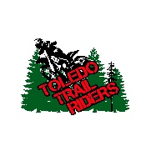
RELEASE, WAIVER AND HOLD HARMLESS AGREEMENT
The undersigned member of Toledo Trail Riders Inc. (hereinafter referred to as “TTR”) (on his/her own behalf and as the parent/legal guardian of a member) or invitee, visitor or other guest of a member of TTR. (collectively referred to as “Member”) agrees to the following terms and conditions of membership:
Assumption of Risk and Waiver: Member understands and accepts the risks of engaging in any and all riding activities organized or facilitated by TTR, and understands and accepts the unpredictable nature of the trails and the hazards of surface or subsurface conditions. Member understands the resulting injuries, death, and property damage that may result from the accepted risks of engaging in all riding activities, whether off-road, trail, or track activities and is not relying on the Released Parties to this Agreement to list all possible riding-related risks. Member agrees on his/her own behalf and on behalf of his/her minor Member, to at all times be responsible for his/her personal safety, remain financially responsible for his/her medical expenses and waives his/her right to any claims arising from his/her participation in or observation of any riding activities. Member understands the risks and dangers inherent in riding and agrees to assume the risks on his/her own behalf and on behalf of the minor Member, and Member’s guests, visitors, family members, heirs, agents and assigns.
Member affirms that he/she is medically able and physically fit to participate in any event organized or facilitated by TTR and assumes all risks of such participation. Member further understands that there will not be first-aid or emergency medical treatment on-site at any event and authorizes transportation to a hospital for emergency treatment.
Release, Hold Harmless, Indemnification: Member agrees to release and hold TTR, their directors, other members, partners, subsidiaries, affiliates, agents, assistants, managers, officers, representatives, assigns, volunteers, employees, independent contractors, and others acting on their behalf (collectively “Released Parties”), harmless for any illness, injury, death, damage, or other loss (collectively “Losses”) incurred, unless directly caused by their gross negligence or wanton and willful misconduct. Member agrees to indemnify Released Parties against all Losses sustained or suffered by any person or entity (including, but not limited to, anyone a party or not a party to this Agreement), whether caused by Released Parties directly or indirectly, and which shall include the reimbursement of Released Parties’ costs, expenses and attorneys’ fees.
Governing Law: This Agreement shall be construed and enforced in accordance with the laws of the State of Ohio. All disputes relating to the interpretation and enforcement of the provisions of this Agreement shall be resolved exclusively by the federal court or state court located in Lucas County, Ohio and the parties hereto hereby submit to the jurisdiction and venue of the court for such purpose.
Photographs: Member understands that he/she may be photographed, filmed or videotaped at TTR events and hereby grants organizers of any such events the right and permission to use his/her likeness and/or voice for any purpose, including commercial advertising.
-----------------------------------------------------------------------------------------------------------------------------------------------------------------------------
MEMBERSHIP STRUCTURE AND FEES:

Individual – Any person eighteen years of age or older who is interested in developing and maintaining a wide variety of recreational trails is eligible. Membership becomes effective at the time of endorsement and payment of dues.

Jr. Member – Any person seventeen years of age or younger who is interested in developing and maintaining a wide variety of recreational trails is eligible. Jr. Member(s) do not get voting privileges and are subject to parent/guardian approval and signature.

Club or Organization – Any organized group; located within the state of Ohio; sharing these same interests; will be eligible for membership privileges.

Sponsor – Any business or firm interested in supporting the activities and ideals of this organization will be eligible for membership. Sponsor membership requires approval of the majority of the Board of Directors.

Dues Structure - The membership year will be March 1st through March 1st. All dues shall be paid annually by the first of March of each year. Any NEW membership received after September 1st of a calendar year, will be in effect through the next full calendar year. Dues amounts shall be as follows:
Toledo Trail Riders Membership Form

Today’s Date________/________/_________

Membership Options: If you are signing up multiple members (i.e. children for Jr. Members) please put the quantity next to the option below. All Jr. Members that are 17 years of age and younger must have a Guardian/Parent signature below! Each Individual Member must complete their own application.

_________Individual (18 years of age and older) – $15.00 per year

_________Jr. Member (17 years of age and younger) - $5.00 per year

_________Club/Organization – $50.00 per year

_________Sponsor – $50.00 minimum donation

$_________TOTAL DUE

Member(s) Name, DOB, Signature:

1._____________________________________________________ D.O.B_______/_______/_________
(Print Name Legibly)

2._____________________________________________________ D.O.B_______/_______/_________
(Print Name Legibly)

3. _____________________________________________________ D.O.B_______/_______/_________
(Print Name Legibly)

Member/Parent/Guardian Signature:_____________________________________________________________________________________
(Parent or Guardian Signature required if member is 17 years of age or younger)

Cell Phone # ( )______________________

Email Address: _______________________________________________________________________________

Home Address:_______________________________________________________________________________
(Street, City, State, Zip)

Emergency Contact Info:

Name:_______________________________________ Number: ________________________________

Please Complete, Sign, and Return this page along with your membership dues to:

Toledo Trail Riders, Inc.
2545 County Rd. 1
Swanton, OH 43558

